A picture containing clipart

Description generated with very high confidence

Azure 103 Module 4

Hands On - 1

Azure Certification Training

[**support@intellipaat.com**](mailto:support@intellipaat.com)

**+91-7022374614**

**US: 1-800-216-8930(Toll Free)**

**Azure 103 Module 2 , Hands On – 1**

**Create an Azure Storage Account.**

**Step 1:** In Portal search for Storage Account and click on it.

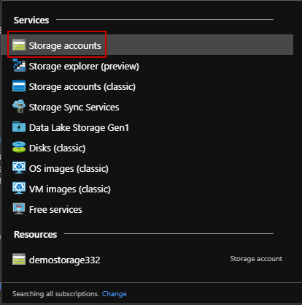

**Step 2:** Click on + Add.

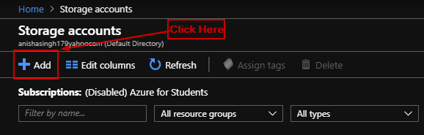

**Step 3:** Enter details.

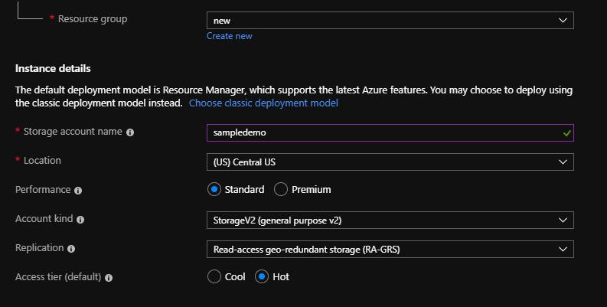

**Step 4:** Click on review + create and then click on create.

